


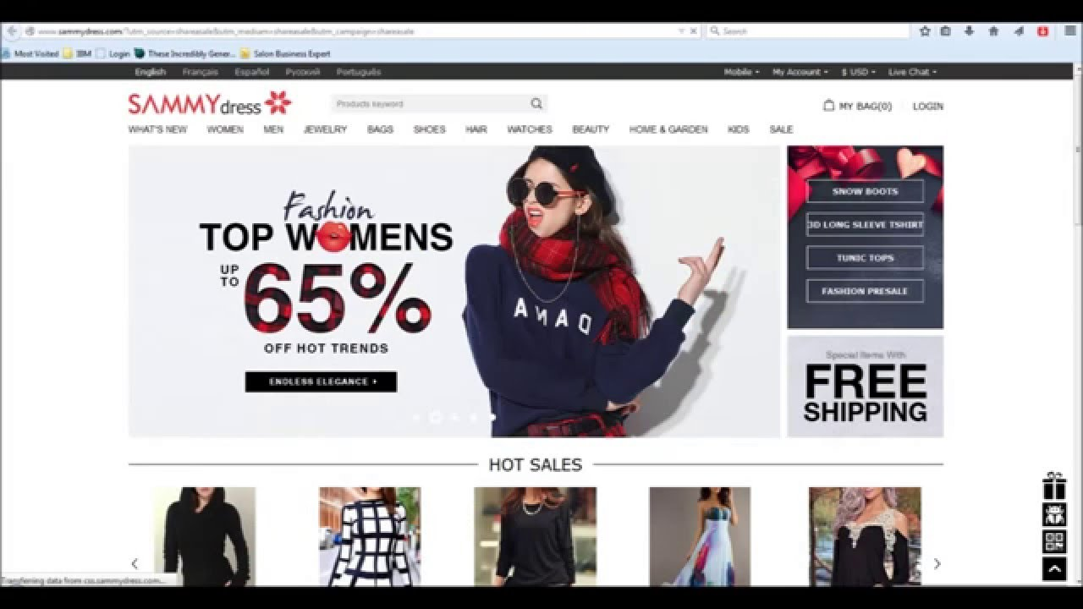
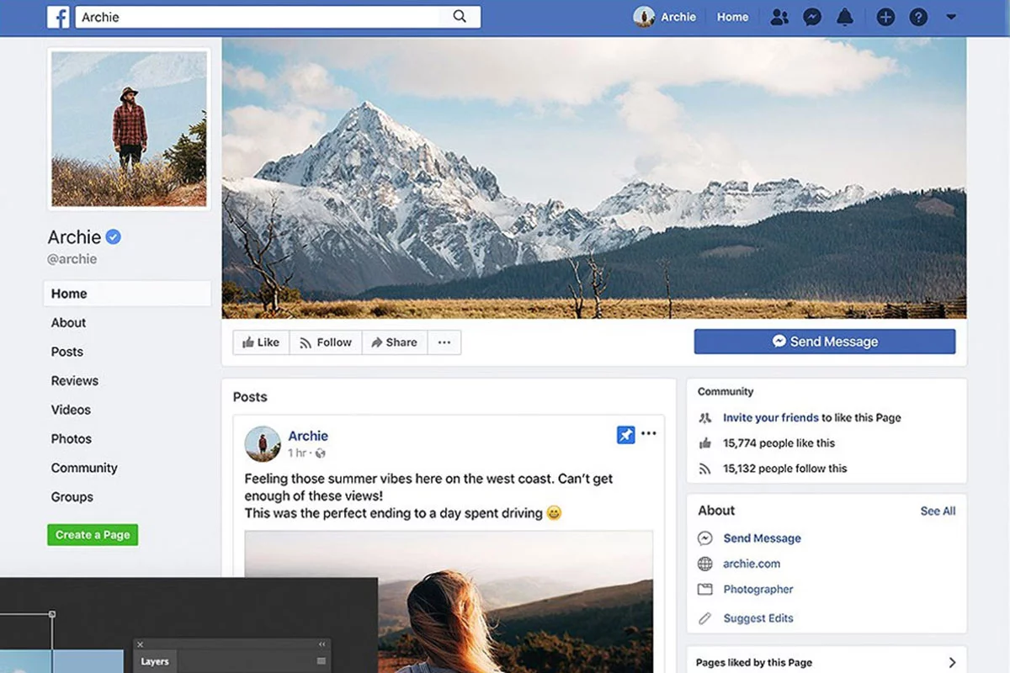
Social Networking Site - Mohamad;)
ABSTRACT:
The purpose of this system is to provide a communication facility to the people. It has two sides:

- User
- Admin

Only registered users can get every facility on this website:

- Log in to their account, see their personal information and modify them.
- Search for another person by name and add him to friends
- Approve/disapprove friendship requests
- Send messages to friends
- Publish posts visible to friends
- See news feed
- Leave comments to visible posts
- Create groups and invite there other users
- Send a request to make his account a "business account"
- For "business account" there should be an option to promote a post (it will be shown in the news feed to requested number of users)

Admin can:

- See all the information about users and posts
- Search for posts with forbidden content and delete them
- Block user activity
- Approve business accounts
- Approve requests for posts promotion

